Township of brick
Community Development Block Grant Program – CDBG
Did you know?
The Community Development Block Grant (CDBG) program is a flexible program that provides communities with resources to address a wide range of unique community development needs. The CDBG Entitlement Program provides annual grants on a formula basis to entitled cities and counties to develop viable urban communities by providing decent housing and a suitable living environment, and by expanding economic opportunities, principally for low- and moderate-income persons.
We provide the following assistance:
- Affordable Housing Opportunities,
- Single and Multi-Family Housing Rehabilitation Grant Funds to make repairs and improvements,
  - Public Service Grants to public or non-profit agencies that provide: Rent, Mortgage and Utility Payments, Employment training, Senior Service assistance, Food bank funding, Counseling services for mental health, domestic violence, youth assistance and Homeless services
We also utilize the funds to make improvements in your neighborhood to improve parks, roads, sidewalks and parks.
If you or someone you know needs assistance and want to know if you’d qualify, please see the table below:

Adjusted Income Limits- Effective July 1, 2022-Ocean County, NJ
HOUSEHOLD SIZE | EXTREMELY LOW  30% LIMITS | LOW INCOME  50% LIMITS | MODERATE INCOME  80% LIMITS
SOURCE: US DEPARTMENT OF HOUSING AND URBAN DEVELOPMENT, JUNE 2022
1 Person | 25,600 | 42,650 | 62,600
2 Person | 29,250 | 48,750 | 71,550
3 Person | 32,900 | 54,850 | 80,500
4 Person | 36,550 | 60,900 | 89,400
5 Person | 39,500 | 65,800 | 96,600
6 Person | 42,400 | 70,650 | 103,750
7 Person | 45,350 | 75,550 | 110,900
8 Person | 48,250 | 80,400 | 118,050
To learn more, please visit the Township of Brick website by using this QR code or go to:
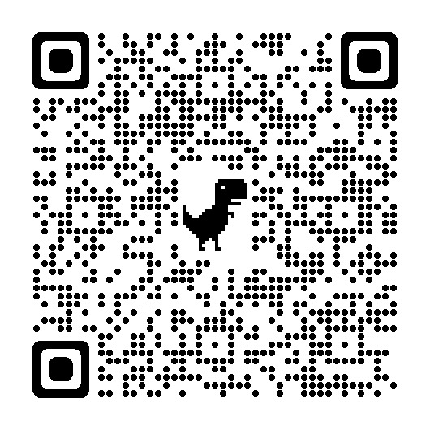
http://www.bricktownship.net/index.php/community-block-development-cdbg-grant-program/
or contact Betty Baptista at bbpatista@bricktownship.net or
Lauren Frank at lfrank@bricktownship.net
For more information, please contact the Township of Brick Community Development Program at 732-262-1030 ext. 5312 or 732-262-1039 ext. 1327

